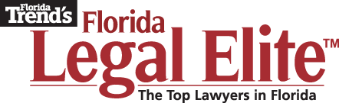

FOR IMMEDIATE RELEASE Contacts:
06/23/15 Andrew P. Corty, Florida Trend Publisher
(727) 892-2638; acorty@FloridaTrend.com

Janice Sharp, Florida Trend Associate Publisher
(727) 892-2621; jsharp@FloridaTrend.com

PETER F. CARR, JR.

ST. PETERSBURG, FL. (June 23, 2015) – Peter F. Carr, Jr., of the Carr Law Firm, P.A., Orlando, was recently recognized in the 2015 edition of Florida Trend’s Florida Legal Elite™. The list of 1,131 honorees, published in the July issue of Florida Trend magazine, includes attorneys in private practice as well as top government and non-profit attorneys.

Actively practicing Florida attorneys were asked to name the attorneys that they hold in highest regard as professionals – lawyers with whom they have personally worked and would recommend to others. "​Florida Trend has grown into one of the state's most trusted media resources and its Legal Elite special report has become the standard for identifying peer-rated attorneys who are among the top legal talent in Florida,” notes Florida Bar President Ramón A. Abadin.

"Florida Trend’s 250,000 readers are executives who rely on the legal community for a multitude of corporate assignments,” says Publisher Andrew Corty. “When we first published Florida Legal Elite in 2004, our goal was to provide a valuable resource for our readers. Over the past 12 years, I’ve heard many accolades about the program. Florida Legal Elite is a guide to selecting a trusted legal partner to handle delicate business concerns. Our website, FloridaTrend.com, offers another pathway for the dissemination of this key information.”

The entire Legal Elite report can be viewed at www.FloridaTrend.com/Legal-Elite.
# # #

